SONARQUBE INSTALLTION

SonarQube:

SonarQube is an open-source platform developed by SonarSource for continuous inspection of code quality to perform automatic reviews with static analysis of code to detect bugs, code smells, and security vulnerabilities on 20+ programming languages

Sonarqube helps to check

Code quality

Code complexity

Loops

Design

bugs

Architecture

**Vulnerabilities** are points in the code which are open to attack. Security Hotspots are security-sensitive pieces of code that should be carefully reviewed by someone with a security auditor hat. This person can be: a member of the development team who is more sensitive to security problems.

Pre-Requisite : Java

Server Specification:

The **SonarQube server** requires at least 2GB of **RAM** to run efficiently and 1GB of free **RAM** for the OS. The amount of disk space you **need** will depend on how much code you analyze with **SonarQube**

Tools using for CI/CD using soanr

1.Git

2.Maven

3.Java

4.mysql 5.7

5.Sonarqube

6.Jenkins

Steps involved

Step1: Launch ubuntu server and Install all basic packages needed.

Installations:

🡪sudo apt-get update

🡪sudo apt-get install default-jdk

🡪sudo apt-get install maven

🡪Install Jenkins

<https://www.digitalocean.com/community/tutorials/how-to-install-jenkins-on-ubuntu-18-04>

🡪Install mysql 5.7 and create users (please follow our blog to install)

<https://www.fosstechnix.com/install-mysql5-on-ubuntu/>

Install mysql 5.7

Create user

Create database

Syntax: CREATE USER 'username'@'%' IDENTIFIED BY 'password';

CREATE USER 'sonar'@'%' IDENTIFIED BY 'sonar';

GRANT ALL PRIVILEGES ON * . * TO 'username'@'%';

GRANT ALL PRIVILEGES ON * . * TO 'sonar'@'%';

FLUSH PRIVILEGES;

Creating database:

CREATE DATABASE sonar;

🡪Installing SonarQube:

Download Sonar

cd /opt/

sudo wget <https://binaries.sonarsource.com/Distribution/sonarqube/sonarqube-7.1.zip>

sudo apt-get install unzip

sudo unzip sonarqube-7.1.zip

sudo mv sonarqube-7.1 sonar

Now make configuration changes in sonarqube

sudo vi /opt/sonar/conf/sonar.properties

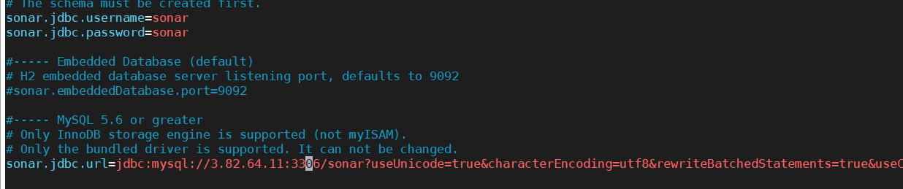

Next Add sonar to Group

sudo groupadd sonar

Now add the user with directory access

sudo useradd -c "user to run SonarQube" -d /opt/sonar -g sonar sonar   
sudo chown sonar:sonar /opt/sonar -R

Edit the sonar script file and set RUN_AS_USER

sudo vim  /opt/sonar/bin/linux-x86-64/sonar.sh

RUN_AS_USER=sonar

Now switch to Sonar user and start sonar

cd /opt/sonar/bin/linux-x86-64/

./sonar.sh start

./sonar.sh status

Now Login to Sonar

<http://3.82.64.11:9000/projects>

Now Generate Token

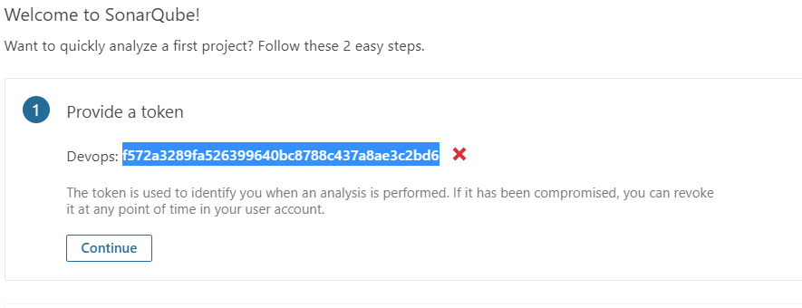

Now Jenkins Part:

* Create a job with Maven Goals
* Install sonarqube scanner plugin

Make GlobalTool and configuration part:

Configure sonarqube in Jenkins

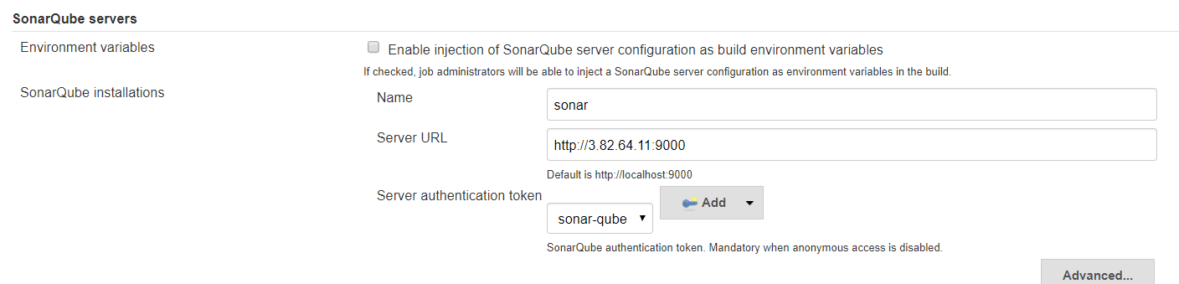

In the above scenerio im unable to add password for that I am following below method to add password

Manage jenkins --> GlobalTool configuration --> sonarqube scanner --> select your version and save it

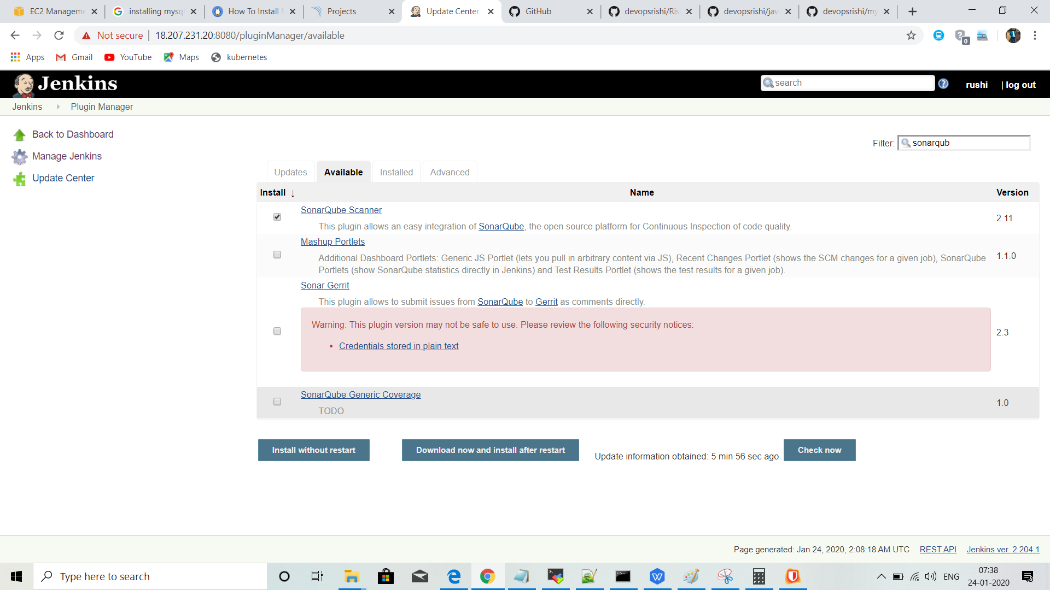

Step2:

Now you can add passwod

Go to jenkins --> configuration ->add credentails --> select kind secret test

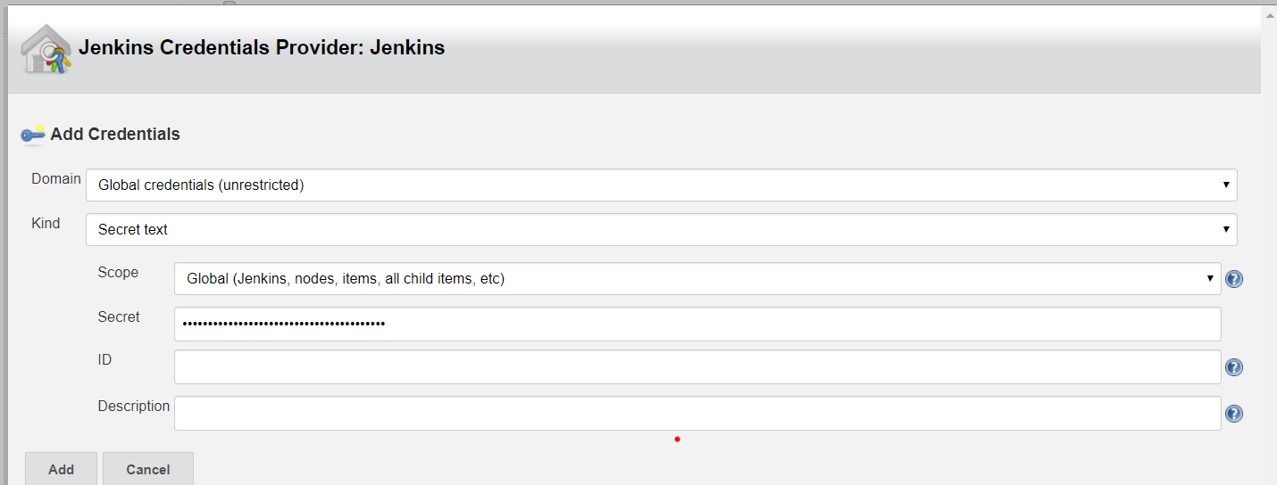

Now Job Jenkins job configuration:

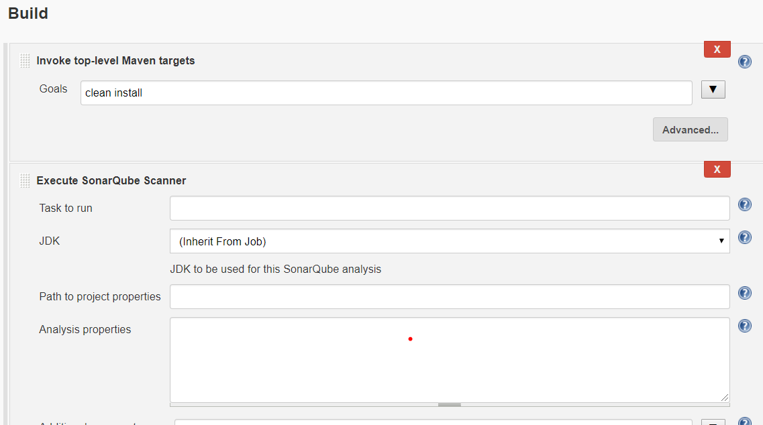

Analysis Properties format:

sonar.projectKey=electricity(anything)

sonar.projectName=job3

sonar.projectVersion=1.0

sonar.host.url=http://54.175.232.9:9000

sonar.login=admin

sonar.password=admin

sonar.language=java

sonar.sources=./

sonar.sourceEncoding=UTF-8

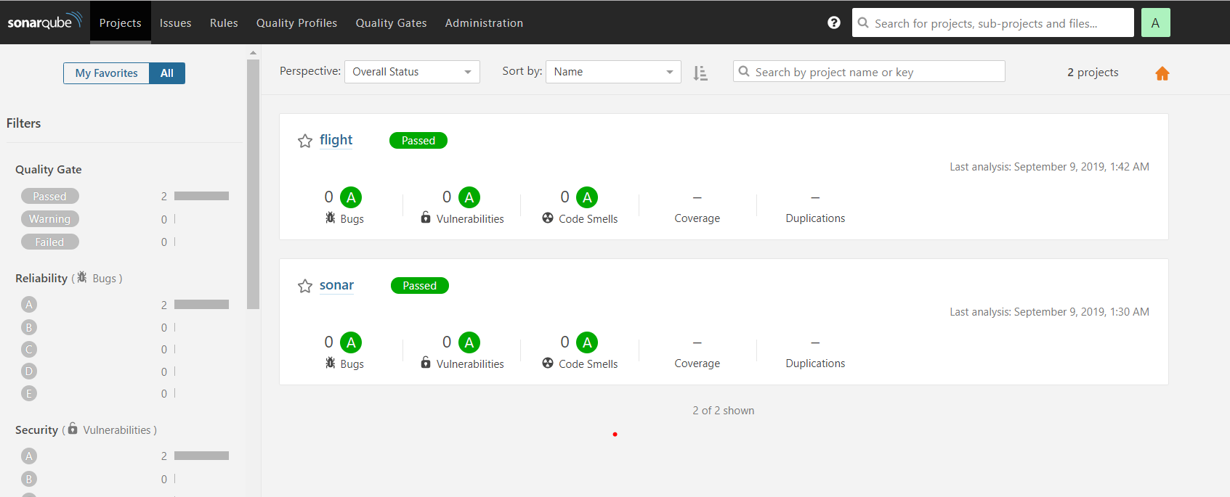

************************************************ STOP YOUR SERVER******************************************